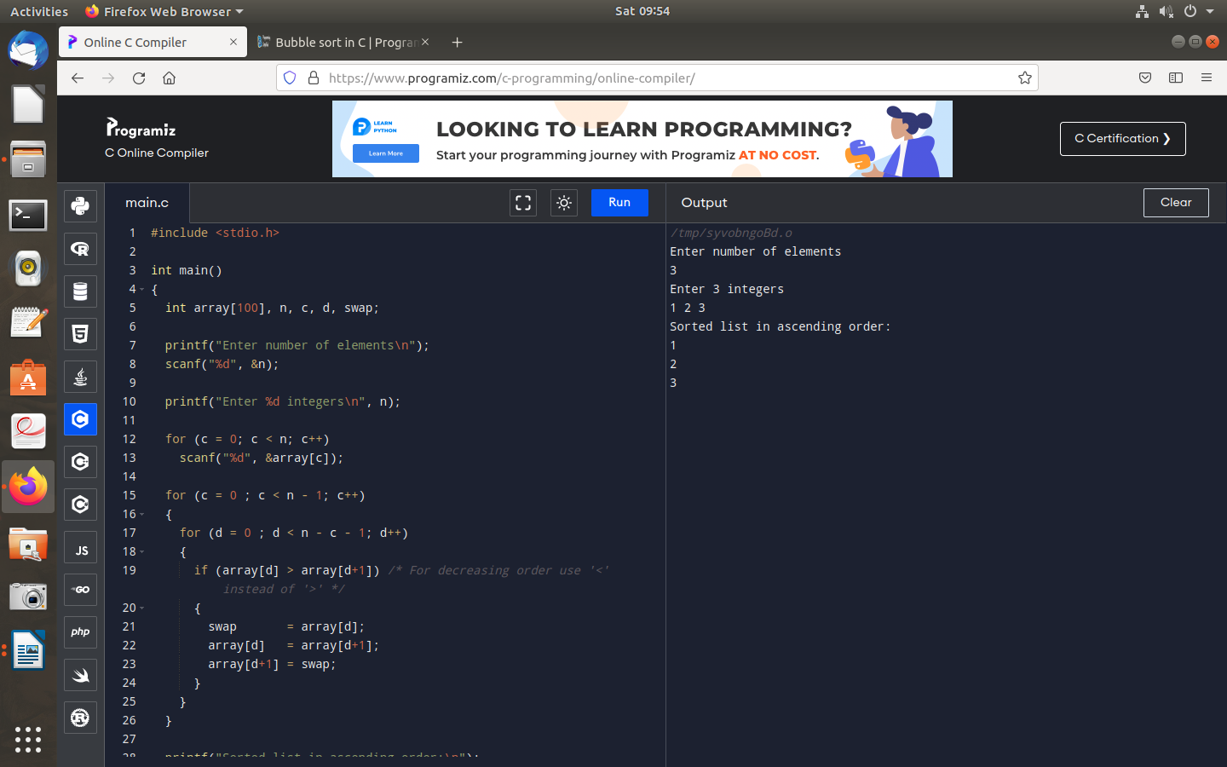
1.Write a c program to implement bubble sort algorithm.

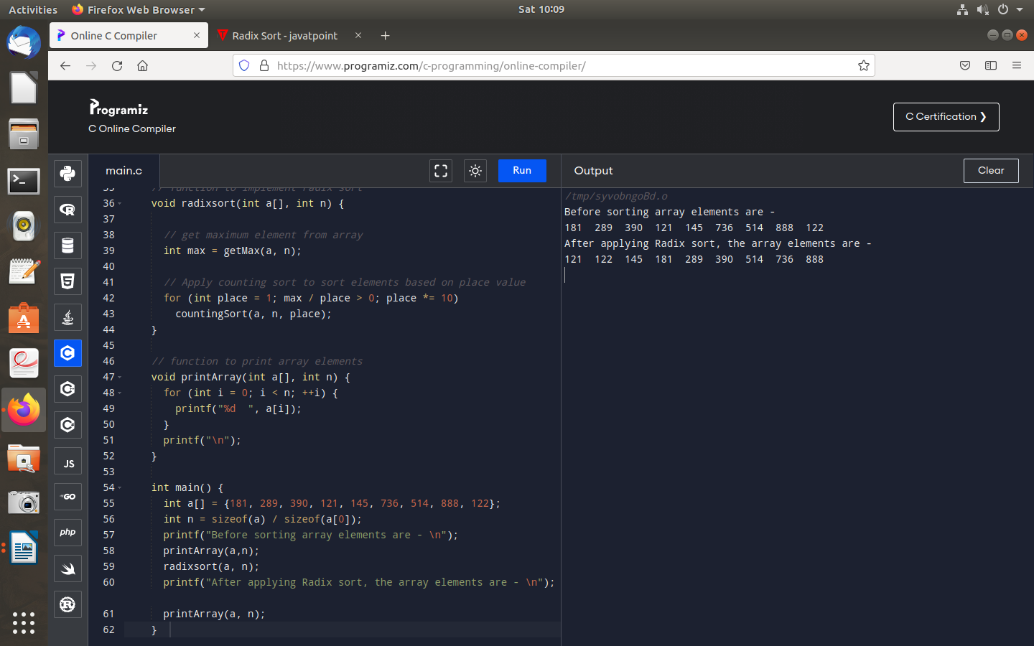
2.Write a c program to impement radix sort algorithm.

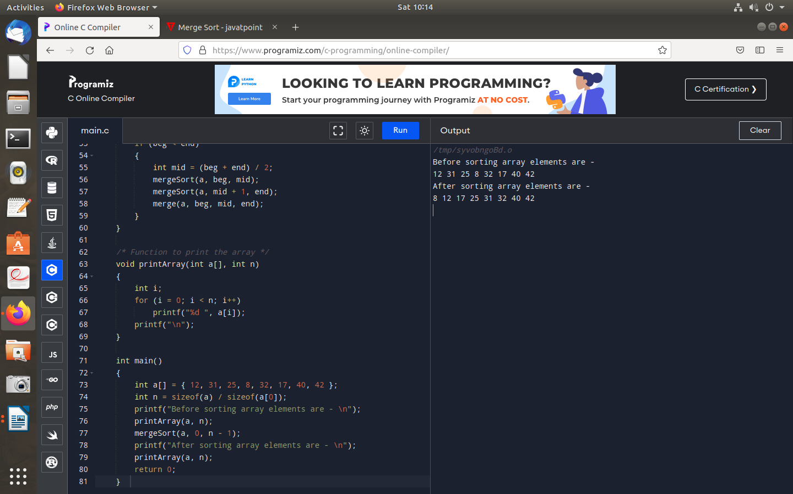
3.Write a c program to implement merge sort algorithm.

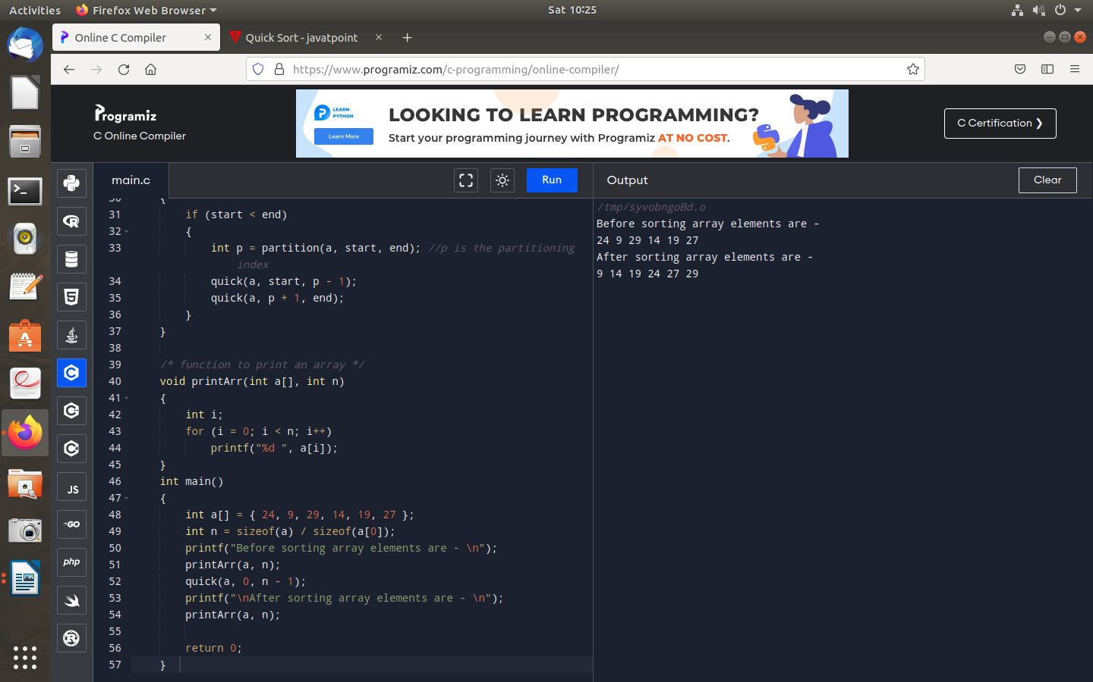
4.Write a c program to implement quick sort algorithm.

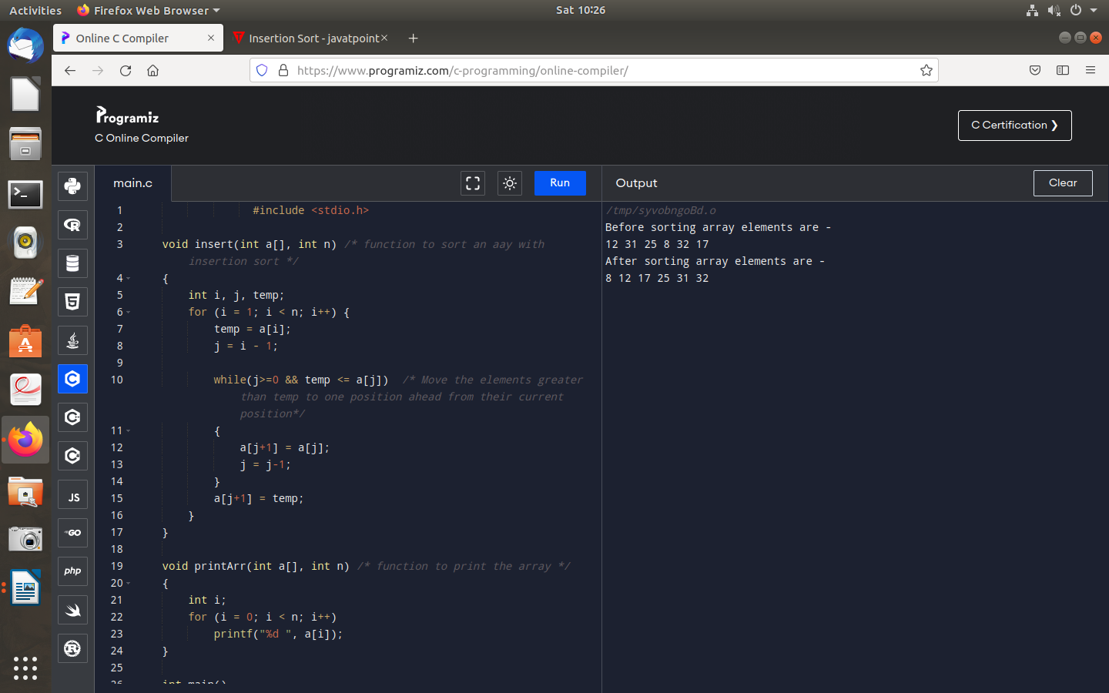
5.Write a c program to implement insertion sort algorithm.

